**Learning Outcomes**

1. Understanding cloud based data storage
2. Kinvey SDK





**Sign up to Kinvey**

https://console.kinvey.com/sign-up.

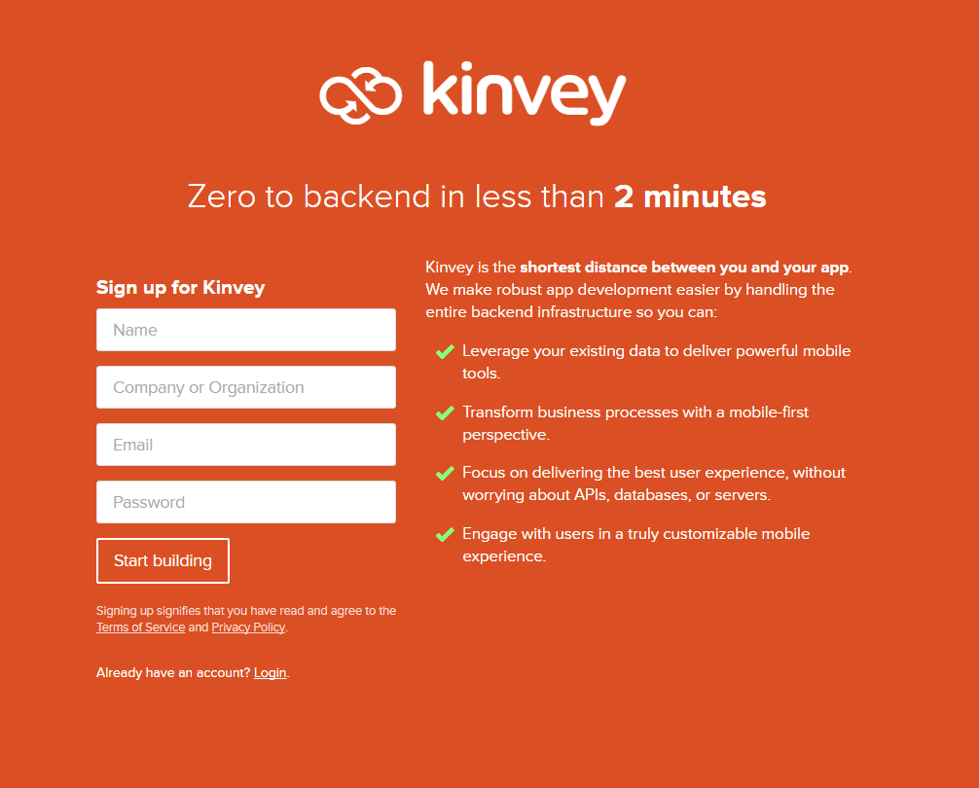

After the Sign Up login to your account

Create your app backend

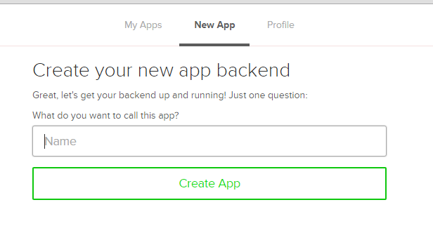

Read the Kinvey Documentation

http://devcenter.kinvey.com/xamarin/

**A simple Book Database**

1. Start a new Project
2. Create a layout as shown

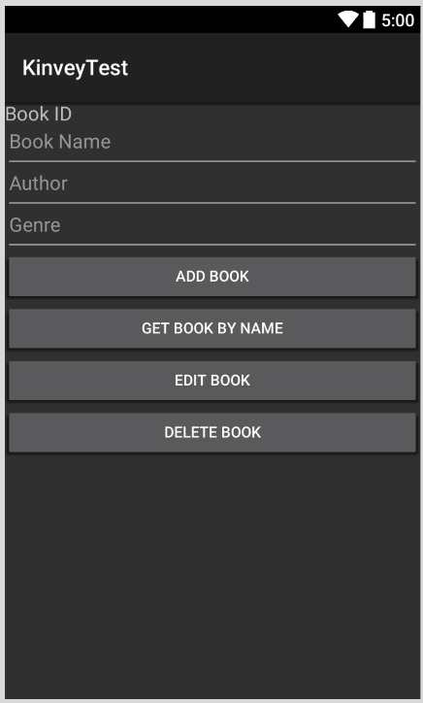

1. Next we need to setup the Kinvey library

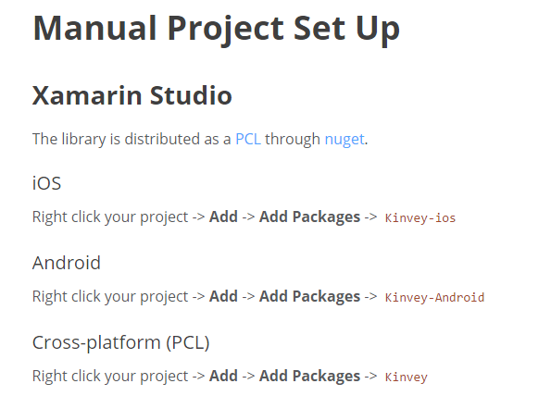

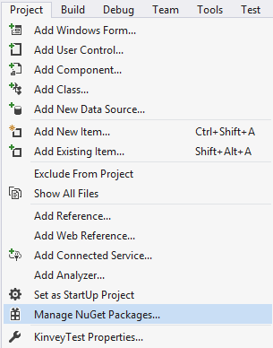

1. Search for Kinvey Android and click Install

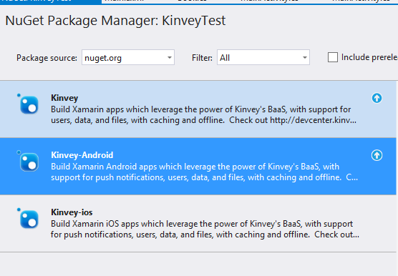

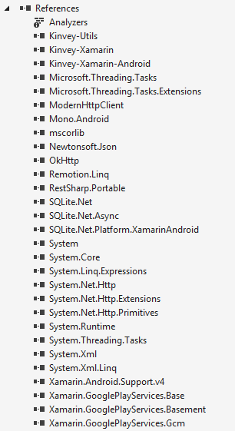

1. Solve any errors that you may encounter with the installation of Kinvey Library
2. Finding out your API keys

In your Kinvey dashboard, click on the link at the bottom which says API Keys.

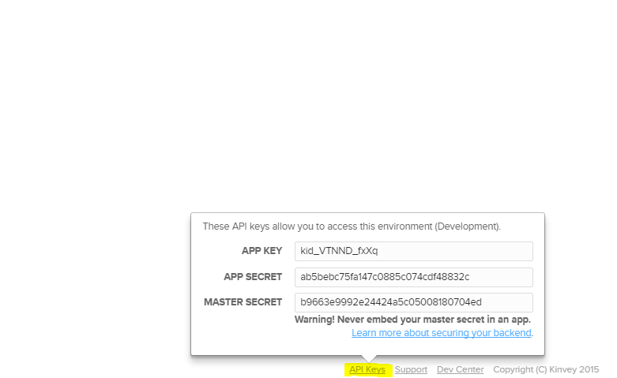

Copy the app key and the app secret

**MainActivity.cs**

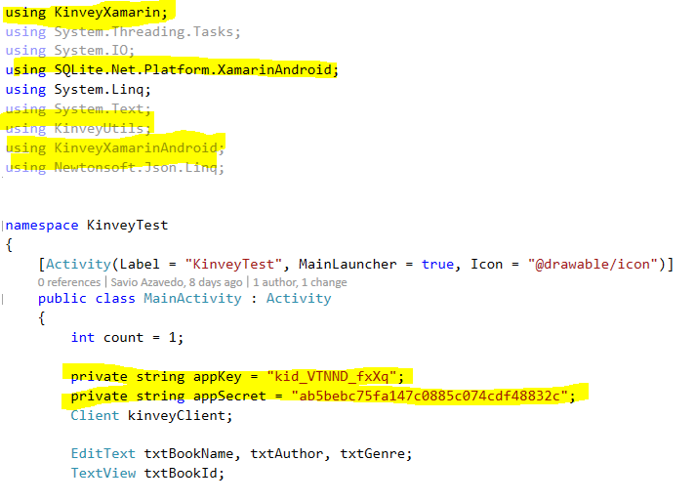

Paste your app key and app secret

Code the OnCreate

Kinvey Android client creation can be found in their documentation

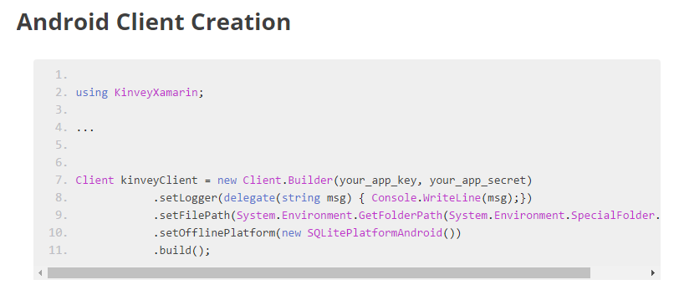

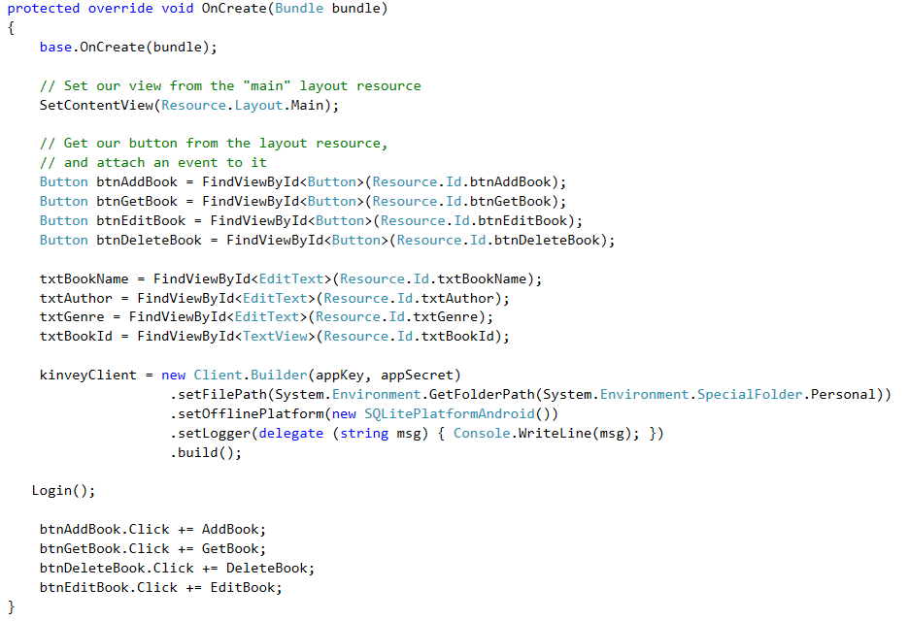

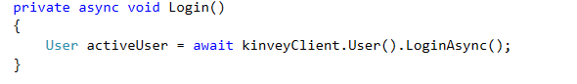

Run the project and see if your Login is successful, and that there are no exceptions.

Now you need to code the Book class

Read through the documentation for data storage

<http://devcenter.kinvey.com/xamarin/guides/datastore>

Create a new class **Book.cs**

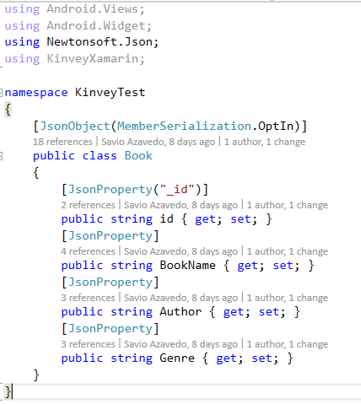

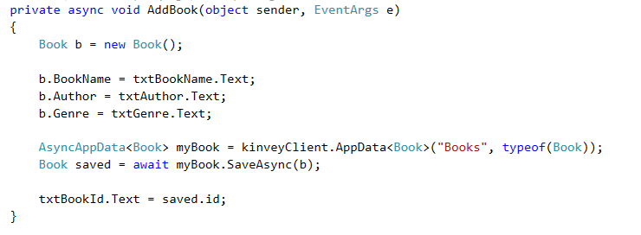

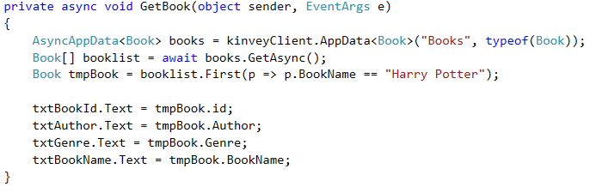

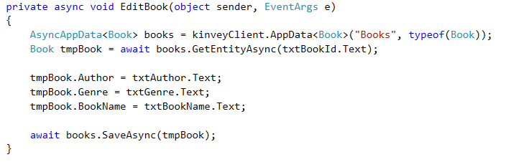

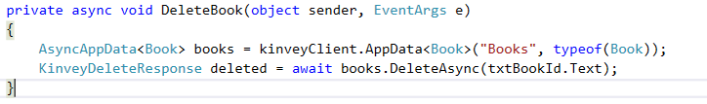

**Exercise**

1. **Create a separate class to store the Kinvey user (client) and also all the database operations should be done from that class (equivalent to a DatabaseManager class).**

**Point to Note – the class should only store one instance of the Kinvey User i.e. the currently logged in user.**